Multiple-choice section – choose the correct answer

Question 1 [1.1]

Choose the correct answer.

The solution to the equation 10 + 2x =  is:



A 2 B -6 C -1.8 D 12

Question 2 [1.1]

The solution to the equation 2(a – 1) = 3(a + 1) is:

A 2 B -5 C 6 D -2

Question 3 [1.2]

The gradient of the equation 4x – 2y = 8 is:

A 4 B 8 C 2 D



Question 4 [1.2]

The gradient of the line with equation x = 7 is:

A undefined B 7 C 1 D 0

Question 5 [1.3]

The equation of a linear graph with a y-intercept of 2 and a gradient of 1 is:

A y = x + 2 B y = 2x + 1 C x = 2 D y = x – 2

Question 6 [1.4]

The line that is parallel to the line with the equation is:



A B C D



Question 7 [1.4]

The gradient of a line that is perpendicular to the line with equation is:



A 2 B -2 C D



Question 8 [1.5]

The solution to the inequality is:



A x = 5 B x < 5 C x > 5 D



Question 9 [1.5]

Which of the following is not a solution of  < 1?



A x = 0 B x = -1.5 C x = -0.9 D x = 2.1

Question 10 [1.6]

The simultaneous equations y = 2x and y + x = 15 have the solution:

A x = 10, y = 5 B x = 0, y = 10 C x = 5, y = 10 D x = 15, y = 2

Multiple-choice results: ___ / 10

Short answer section

Question 11 10 marks

Use words from the list below to complete the following sentences.

linear relationship y = mx + b perpendicular linear equation inequality one inverse operations gradient parallel rise over run y-intercept

(a) A linear relationship is described by a ______________________________ .

(b) Linear equations can be solved by applying _______________________________________ to both sides of the equation.

(c) The ______________________of a line is a measure of its steepness, which can be evaluated by evaluating the fraction ______________________________.

(d) The general equation of a straight line is _____________________ where m is the gradient of the line and b is the ________________________ of the line.

(e) Lines that are ___________________ have the same gradients.

(f) Lines that are _______________________________ meet each other at an angle of 90°.

(g) A linear equation has _____ solution and a linear _______________________ has a range of solutions according to the inequality.

Question 12 4 marks [1.3, 1.4]

The line with equation y = x is shown on the graph. State an equation of a line that is (a) parallel to and (b) perpendicular to the line y = x. Sketch each line on the graph below.

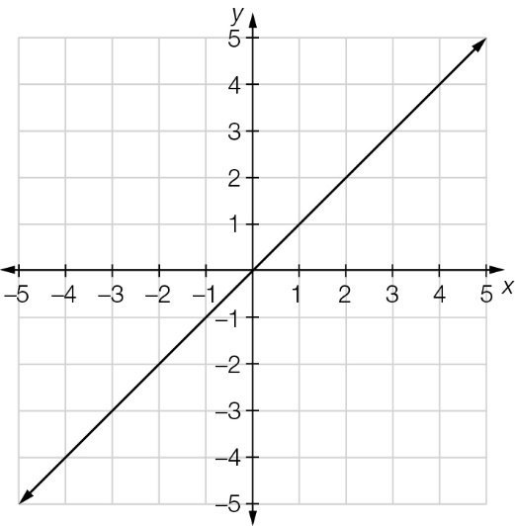

Question 13 3 marks [1.1]

Solve the following equation.



Question 14 4 marks [1.1]

Solve the following equation.

3(3x – 2) = 2(2x + 2)

Question 15 2 marks [1.2]

Find the gradient of the line joining the points (1, 3) and (4, 9).

Question 16 2 marks [1.2]

Find the gradient of the line.

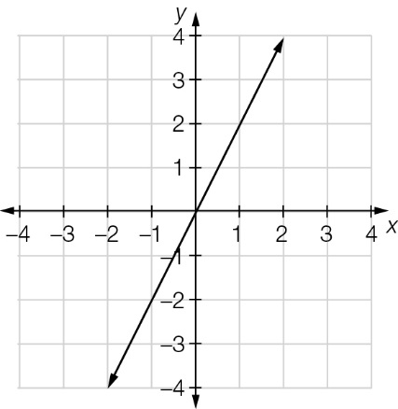

Question 17 2 marks [1.3]

Sketch the graph of y = 2x + 2.

Question 18 4 marks [1.4]

(a) Show that the line with equation y – 2x = 5 is parallel to the line with equation y = 2x + 2.

(b) Show that the line with equation y = x + 3 is perpendicular to the line with equation y = -x + 2.

Question 19 4 marks [1.5]

Solve the following inequalities.

(a) 2x ≥ 16 (b) 5x – 3 < 7

Question 20 4 marks [1.5]

Show each of the following on separate number lines.

(a) x ≥ 4

(b) x < -3

Question 21 4 marks [1.6]

Solve this pair of simultaneous equations.

y = x + 2

2x + y = 11

Question 22 4 marks [1.6]

Solve this pair of simultaneous equations.

x – 2y = 14

3x + 2y = 2

Short answer total:_________/47

Extended answer section

Question 23 4 marks [1.1]

The perimeter of this triangle is 19 cm. Find the lengths of the sides of the triangle.

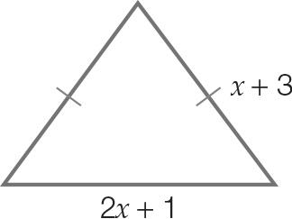

Question 24 5 marks [1.5]

Callie bought 2 books and 3 pens for $11. Una bought 1 book and 1 pen for $5.   
How much did each book and each pen cost?

Question 25 4 marks [1.6]

A baker uses dried fruit in the fruit buns she makes.

There is 200 g of dried fruit in the last bag and each bun uses 10 g of dried fruit ingredients.

(a) Write an inequality that describes the baker’s situation.

(b) Solve the inequality to find out how many buns could be made.

Question 26 10 marks [1.2, 1.3, 1.4]

(a) Sketch the line with equation y = x + 8 on the set of axes below.

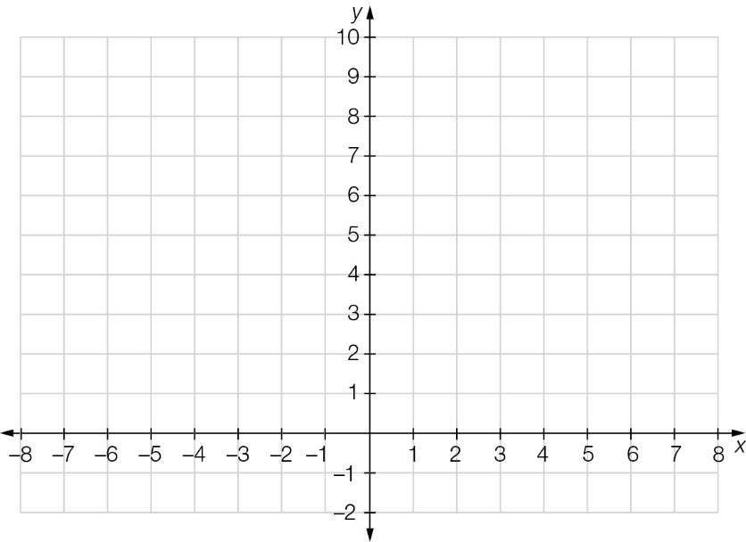

(b) (i) Draw the line AB that passes through the points A(2, 0) and B(5, 3).  
Write the equation of the line AB.

(ii) Prove that the line with equation y = x + 8 is parallel to the line AB.

(c) (i) Draw the line CD that passes through the points C(-3, 7) and D(4, 0).  
Write the equation of the line CD.

(ii) Prove that the line with equation y = x + 8 is perpendicular to the line CD.

Extended answer total:_______/23

TOTAL test results: ______ / 80